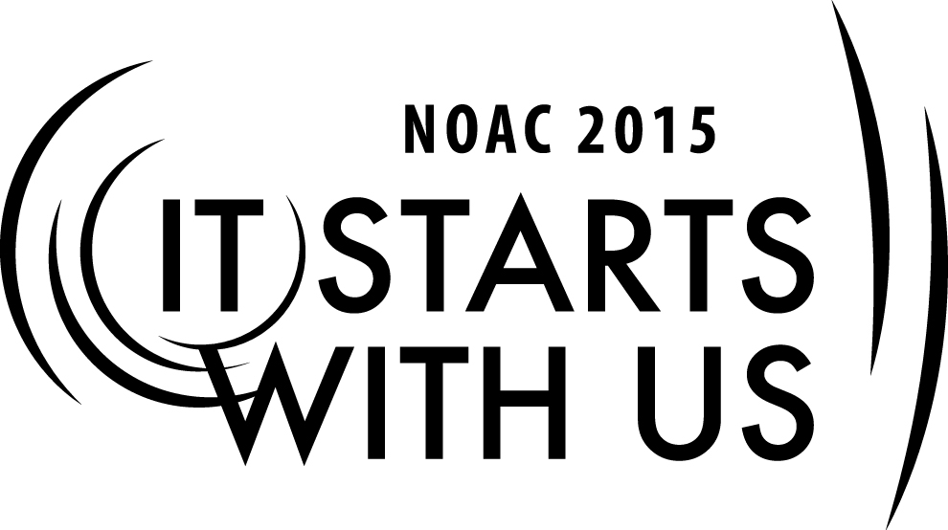

**Chapter Operations: My Chapters Path**

2015 National Order of the Arrow Conference

Session Length: 50 - 55 Minutes

Through this session, you will:

**Explain** the role of the chapter and roles and responsibilities of chapter leaders.

**Demonstrate** importance of chapter leaders in building successful chapters.

**Guide** participants in establishing baselines for where their chapters are.

**Enable** participants to identify the direction or “path” they want their chapters to go – establishing measurable Chapter Goals and defining strategies to reach their Chapter Goals.

This session will help the Chapter with the Journey to Excellence Requirement(s) #’s 1 – 15. Potentially any and all JTE requirements can be incorporated into the planning and metrics discussed in this session.

The theme of NOAC 2015 is “It Starts With Us”. This session will relay this theme in the following ways:

* Empowering youth and adults to take ownership of their chapter’s success in the present, and plan for success in the future.

**SESSION NARRATIVE**

**INTRODUCTION 5 Minutes**

**Trainer Instructions:** Facilitate round-robin introductions; write cities/states/lodges and positions on whiteboard or flip-chart if desired to help illustrate breadth of experience.

Instructors and participants introduce themselves, where they are from, and what position they hold in their Chapter.

**MY CHAPTER’S PATH 10 Minutes**

**Trainer Instructions:** Present the learning objectives (Slide 2)

.

Learning Objectives

* Identify the role of the chapter
* Identify the roles and responsibilities of chapter leaders
* Establish baseline of where your chapter is
* Identify the direction or “path” you want your chapter to go - Establish measureable Chapter Goals
* Define strategies in reaching Chapter Goals

**Trainer Instructions:** Ask the question: “What is the role of the Chapter?” (Slide 3)

Collect responses on a board or flip chart

Desired responses include:

Comply with National Mission Statement –

**Boy Scouts of America**

**Mission Statement**

The mission of the Boy Scouts of America is to prepare young people to make ethical and moral choices over their lifetimes by instilling in them the values of the Scout Oath and Scout Law.

**Scout Oath**

On my honor I will do my best to do my duty to God and my country and to obey the Scout Law; to help other people at all times; to keep myself physically strong, mentally awake, and morally straight.

**Scout Law**

A Scout is trustworthy, loyal, helpful, friendly, courteous, kind, obedient, cheerful, thrifty, brave, clean, and reverent.

**Vision Statement**

The Boy Scouts of America will prepare every eligible youth in America to become a responsible, participating citizen and leader who is guided by the Scout Oath and Scout Law.

**Order of the Arrow**

For more than 90 years, the Order of the Arrow (OA) has recognized Scouts and Scouters who best exemplify the Scout Oath and Law in their daily lives.  This recognition provides encouragement for others to live these ideals as well.  Arrowmen are known for maintaining camping traditions and spirit, promoting year-round and long term resident camping, and providing cheerful service to others.  OA service, activities, adventures, and training for youth and adults are models of quality leadership development and programming that enrich and help to extend Scouting to America's youth.

**Mission**

The mission of the Order of the Arrow is to fulfill its purpose as an integral part of the Boy Scouts of America through positive youth leadership under the guidance of selected capable adults.

**Purpose**

As Scouting’s National Honor Society, our purpose is to:

* Recognize those who best exemplify the Scout Oath and Law in their daily lives and through that recognition cause others to conduct themselves in a way that warrants similar recognition.
* Promote camping, responsible outdoor adventure, and environmental stewardship as essential components of every Scout’s experience, in the unit, year-round, and in summer camp.
* Develop leaders with the willingness, character, spirit and ability to advance the activities of their units, our Brotherhood, Scouting, and ultimately our nation.
* Crystallize the Scout habit of helpfulness into a life purpose of leadership in cheerful service to others.

(Last revised on October 15, 2009)

To support the Lodge and Lodge activities

To support the District in promoting camping

To provide a program for the youth Arrowmen

* Broad themes may include developing youth leadership beyond the troop, promoting membership retention and more activities for older youth in their troops and in scouting, supporting Webelos to Scout transitions, etc

**Trainer Instructions:** Collect responses on a board or flip chart

Show slide and compare (Slides 4, 5, 6 & 7)

Ask the question “What is the Role as a Chapter Leader?” (Slide 8)

First Need to identity the Chapter Positions “What are the Chapter Leadership Positions?” (Slide 9).

Desired responses include:

* Chapter Advisor
* Chapter Chief
* Chapter Vice-Chief
* Chapter Secretary
* Chapter Treasurer
* Chapter Elections Vice-Chief

**Trainer Instructions:** Quote on measurement by Thomas S Monson (Slide 11)

Establish baseline of where your chapter is:

What are your current Chapter metrics? (Slide 12)

“Before we know where we are going,

we need to know where we are at.”

Desired responses include:

Elections

Total Members

Total Due paying members

Number of elected youth (and adults) going through the Ordeal

Number of new Ordeal members attending a chapter meeting or activity within 60 days of their Ordeal

Total attendance at chapter meetings

Total attendance at activities

Numbers of Ordeals eligible for Brotherhood

Brotherhood conversion

Honor chapter requirements and compliance

Youth members elected to Lodge Offices

Vigil Honor members and participation

**Trainer Instructions:** Collect responses on a board or flip chart and record Positions

Show slides and compare (Slide 13)

Establish Measurable Chapter Goals:

**Trainer Instructions:** Discuss establishing measureable Chapter Goals:

“Where do we want to be?” (Slide 14)

Desired responses include:

Increase elections

Increase Total Members

Increase Total Due paying members

Increase Total attendance to chapter meetings

Increase Total attendance to activities

Numbers of Ordeals eligible for Brotherhood

Honor chapter requirements and compliance

**Trainer Instructions:** Collect responses on a board or flip chart and record Positions

Show slides and compare (Slide 15)

**STRATEGIES IN REACHING CHAPTER GOALS 15 Minutes**

**Trainer Instructions:** “How do we accomplish the goals?” (Slide 16)

The participants will (Slide 17)

* Break into 3 groups
* Take the assigned goals and outline strategies (15 minutes)
* Select a presenter to represent the group (youth)
* Be prepared to share your responses with the rest of the class

(Slide 18)

Group 1

* Increase elections
* Increase Total Members

Group 2

* Increase Total Due paying members
* Increase Total attendance to chapter meetings

Group 3

* Increase Total attendance to activities
* Numbers of Ordeals eligible for Brotherhood
* Honor chapter requirements and compliance

.

This will be a 15 min break out session to allow different groups to come up with strategies to address their specific assigned topic from the list of 7 above or any others the group may come up with.

**GROUP PRESENTATIONS & SHARING 15 Minutes**

**Trainer Instructions:** Have groups present their results (Slide 19)

Collect responses on a board or flip chart and record

Facilitate discussion as needed with open-ended questions.

**CONCLUSION 5 Minutes**

**Trainer Instructions:** Conclusion (Slide 20)

* Define – Roles, responsibilities and metrics
* Measure – Where we are
* Establish – Set reachable goals
* Implement – Pit into action
* Analyze – What does the data say?

Action – Follow the data

“Now you’re on the right path”

Summarize emphasizing that every chapter has different needs but the most important aspect is to identify were you are and where you need to go to accomplish your goals (your mission and purpose).

“Defining the path you are on, will determine the path you will need to take”

**TRAINER PREPARATION**

Trainers presenting this session should be experienced youth and/or adult chapter leaders (chiefs and/or advisers) with personal experience in running a successful chapter. Good public speaking skills and a high level of energy and enthusiasm will make for an exceptional training experience.

Appendix Resources:

Recommended Flipcharts/Slides

|  |
| --- |
| Slide 1   * Cover Slide |
| Slide 2   * Learning Objectives |
| Slide 3   * What is the role of the Chapter? (Question) |
| Slide 4   * What is the role of the Chapter? (List) |
| Slide 5   * What is the Role as a Chapter Leader? (Question) |
| Slide 6   * What are the Chapter Leadership Positions? |
| Slide 7   * What is MY Role as a Chapter Leader? (Question) |
| Slide 8   * Quote on measurement by Thomas S Monson |
| Slide 9   * What are your current Chapter Metrics? (Question) |
| Slide 10   * What are your current Chapter Metrics? (List) |
| Slide 11   * Where do you want your chapter to be? (Question) |
| Slide 12   * Where do you want your chapter to be? (List) |
| Slide 13   * How do we accomplish these goals? (Question) |
| Slide 14   * How do we accomplish these goals? (Activity) |
| Slide 15   * How do we accomplish these goals? (Assigned Tasks) |
| Slide 9   * Group Presentations |
| Slide 10   * Conclusions |

Source Materials and Resources

* Order of the Arrow Website – Chapter Operations Guide 2, Revised September 2012

<http://www.oa-bsa.org//uploads/publications/cog-2012.pdf>

* By This Shall Men Know -- Sunday Feb 8, 2009

<http://bythisshallmenknow.blogspot.com/2009/02/how-to-accelerate-performance-thomas-s.html>