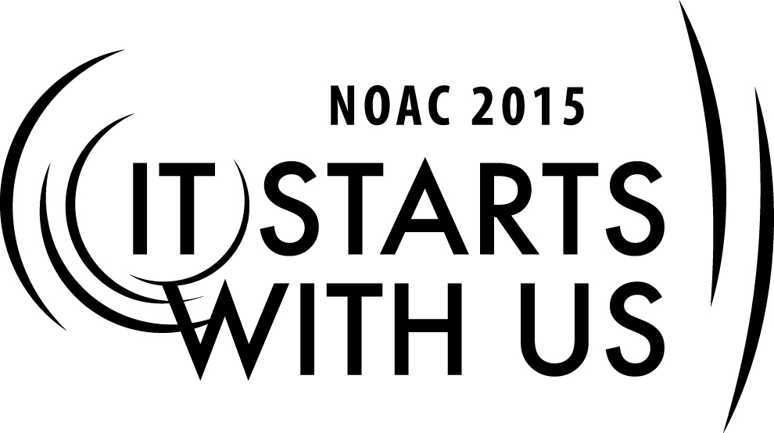
Panning for Gold: Knowing your Members
2015 National Order of the Arrow Conference

Session Length: 50 Minutes
Through this session, you will:
Explain: The importance of good relationships with your key customer resources to successful fundraising.
Demonstrate: How to identify your key resources
Guide: How to build and maintain beneficial relationships with your key resources
Enable: Expand and improve the Lodge’s ability to conduct successful annual fundraising

This session will help the Lodge with the Journey to Excellence Requirement(s)
- Fiscal Management – “Develop and successfully execute a lodge annual budget.”
- Contribution to Council – “Contribute cash, materials or both to the council.”

The theme of NOAC 2015 is “It Starts With Us”. This session will relay this theme in the following ways:
- By taking action today to develop and execute an annual, ongoing, successful fundraising program, Lodges will improve their ability to remain financially sound for the next century of service.
- By starting the process today to know your Members and know your Council and Community better, you will be able to better utilize these resources to support your finances and fundraising
SESSION NARRATIVE

Introduction: 5 Minutes
“The National OA Committee and all lodges are financially stable with balanced budgets, appropriate cost structures and diversified funding models.”
Toward a Second Century of Service – The Order of the Arrow Strategic Plan 2013 - 2017
In order to accomplish the many events and projects a lodge undertakes in support of the mission of Scouting, it is necessary to have sufficient funds to cover the costs of those projects and events. This session will give you both ideas and tools to determine the best way identify resources in the lodge, your Council and Community and ways to fundraise to insure a financially stable lodge.
The first place to start is by identifying our key Customers/Supporters:
A basic premise of successful fundraising is that “donors like to give to organizations and causes that they understand and connect with.” But, as this very short description indicates, there are four issues that must be addressed.
Donors – Who are they?
Cause – What is the Lodge “cause”
Understanding – How do donors understand the Lodge?
Connection – How do donors connect with the Lodge?
Understanding the interplay of these issues enables the Lodge craft a better fundraising strategy and implement it.

Trainer Tip
This section will create a matrix with donor type across the top and resources, motivation, communication and “the ask” along the vertical axis, as so:
Members Parents Unit Leaders Former Arrowmen Friends
Resources
Motivation
Communication
The Ask
Work with the audience to elicit replies and record on the white boards

II. Donors 10 Minutes
A. Stakeholders
A person, group or organization that has interest or concern in an organization.

Trainer Tip
Ask the audience to think and respond with stakeholders in terms of closeness to current lodge activities or distance from current lodge

B. Who are the stakeholders in the Lodge?
1. Members: Who are our members?
a. Dues-paying members of the lodge
b. <18 years old members
c. 18-21 year old members (away at college?)
2. One level removed
a. Parents
b. Unit leaders
3 Two levels removed
a. OA alumni
b. NESA membership
c. Camp staff alumni
4. Council level
a. District and Council Board
b. Council corporate sponsors
5. Community
a. Local businesses
b. Local organizations (Rotary, etc.)
c. Other businesses and organizations (patch makers...)

III. The Cause - Dimensions of Affiliation and Interest 10 Minutes
A. Past experience
B. Current experience
C. Beliefs in goals
D. Determining Motivation, Affiliation and Interest
1. Stakeholder surveys
2. Small group discussions (focus groups)
3. Scheduled meetings or brainstorming sessions

Trainer Tip
Motivation to support is not limited to these items. Audience members may identify many more. Since the matrix has been started, attempt to place motivation under one or more of the stakeholder groups

Trainer Tip
EDGE – Trainer will walk the group through this section leading discussion.

IV. Creating Awareness (Marketing) 5 Minutes
A. Multi-dimensional
B. Generational
C. Audience appropriate
D. Means of communication
1. Hard copy
2. Digital
3. Frequency and rules

Trainer Tip
The list created here may be long. As in the Motivation section above aspects of communication specific to a stakeholder group should be assigned to that stakeholder group.
The list that is created may be long. Time used should be monitored to keep the total session on time.

Trainer Tip
EDGE - “Guide” - Break the audience into groups to work out the answers to the means of communication part of this. Ask for groups to provide answers.

V. Connection 3 Minutes
A. How does the Lodge connect with stakeholder groups?
B. Medium of connection
C. Events and participation
5 Minutes
VI. Resources
A. Purpose of “fundraising” to raise funds (money) for the Lodge, but is it just money?
B. Money is fungible – that which is received for one use can free funds for another use
C. Gifts in kind
1. Eagle project materials from Lowes/Home Depot
D. Which stakeholder has which resource
1. Age, demographic, geography
VII The Ask 7 Minutes
A. Review: Why People Give
1. Because they believe in the organization and its cause or purpose
B. They were asked....
2. The Woodbadge “fist game”

Trainer Tip
This a game played early in the Woodbadge syllbus where one player makes a fist and the second player attempts to get the first player to open his or her fist. The game is played in pairs.

C. Game Results
1. Who opened when asked?
2. Who required additional incentive?
a. “hot buttons”: an item that causes a strong emotion reaction
i. Often given a negative connotation – an issue or item that obtains and angry reply
ii. Here, seeking a positive reaction, an item that appeals to positive emotions and seeks a positive response.
D. Details of the Ask
1. Who asks?
a. The asker must have a connection to the organization and must have a connection to the asked.
2. How much to ask for?
a. The delusion of simplicity
i. Everybody just gives $10 – nominal, seeming painless
ii. Funding pyramid

Trainer Tip
A powerpoint slide showing the pyramid to be show.

3. How to ask
a. Letter, email
b. Personal contact
c. Personalize
d. Hot Buttons

Trainer Tip
The matrix is now full.
The next two sections are transitional. The first concerns implementation. The second introduces the next section of the workshop.

VII. Implementation and Getting Started 5 Minutes
A. Anywhere, any time
B. Consistency
C. Moderation
D. On-going
1. It never ends
2. Learn as you go

VIII. Conclusion 2 minutes
A. Fundraising seeks to secure financial and material resources for the continued health of the lodge.
B. As we have seen, people give because they believe in the mission of the Lodge, but there are many variables involved – including who the person is and what resources they have available;
C. Critical in any of this is that the individual gives when asked, but the ask must be personal and reasonable;
D. In the next two sections we will look at how the Lodge puts together its budget and the place of fundraising in that budget, and then at resources available to the Lodge at Council and Community level.

TRAINER PREPARATION

Prior to the session, the trainer should print on a chalkboard, flip chart or overhead projector the following information:
The Session name
Trainer’s name
Contact information
Review materials needed for session
Prepared materials for session
Timeline

This session is designed to be in a classroom format.

