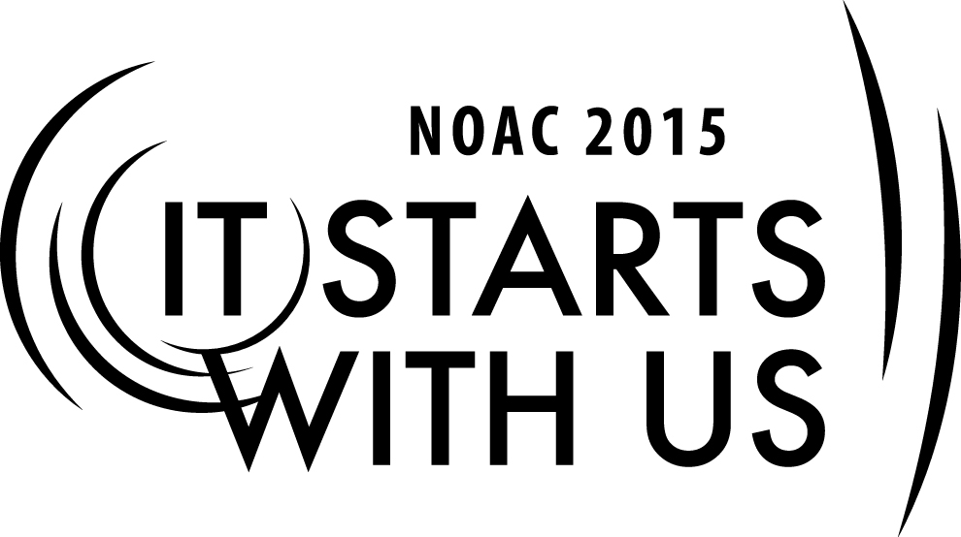

**Planning the Gala:**

**How to’s of an Event**

2015 National Order of the Arrow Conference

Session Length: 50 Minutes

Through this session, you will:

**Explain** how to plan an event.

**Demonstrate** creating an event planning committee.

**Guide** guests in creative event planning methods.

**Enable** guests to plan a quality event back at home.

This session will help the Lodge with the Journey to Excellence Requirement(s): 7: Event Participation

The theme of NOAC 2015 is “It Starts With Us”. This session will relay this theme in the following ways:

* by inspiring participants to create inspiring and dynamic events.
* by demonstrating how the success of an event can be driven by both an individual and a team

**SESSION NARRATIVE**

**Introduction 5 Minutes**

To begin, I’ll need a volunteer. Would you come up. *Check which hand they normally write with*. With the hand you normally write with, I’d like for you to apply this band-aid. But there’s a catch. With your other hand, I’d like for you to sign your name over and over while you apply the band-aid. *Hand them a band-aid still in the wrapper, a pen, and a paper.*

Thanks for your help. As I’m sure everyone noticed, that was pretty difficult. I’m sure that my volunteer could have done each of those tasks separate, but when he tried to do it all himself – and with his weak hand – it became really difficult. That’s not to say that it is impossible, but it was just difficult.

Why then do so many of us try to plan events on our own, even when some parts of event planning are not our strengths? Today’s session will help you discovery ways to plan events while finding other people to compensate for your weaknesses and allow you to focus on only one part of an event at a time.

**SE**

**Trainer Instructions:** This would be an appropriate time to introduce the trainer(s) and discuss your qualifications – keep it brief! Focus on the qualifications that directly relate to event planning.

**The Toolbox 10 Minutes**

Let’s start at the most logical place: the event planning toolbox. What resources do you have at your disposal when planning an event? Here are the keys:

* Council Professional Staff – your council professional staff, whether a staff adviser or another professional, are your first line of resource. They will be able to assist with the finances, the promotions, the insurance, and other logistical support. Essentially, they are your first line for most areas of event planning because it is their job! They plan Scouting events professionally.
* Lodge Budget – consult your lodge treasurer and finance adviser to determine how much money the lodge can contribute to your event. Whether a chapter or lodge event, most lodges will budget some money for events. Whether a Lodge Fellowship or a Chapter night at the bowling alley, check your lodge’s budget.
* Lodge/Council/District Calendar – any event should be placed on the calendar as soon as a date is set. Before a date is set, consult the calendar to minimize conflicts.
* Your pool of team members – Is this a chapter event? Who in the chapter can help? Is this a lodge event? Is there a dedicated committee who will help plan it? Locate your talent and identify the right mix of people to make your event successful.

These are the basics: What would you add to the list? Let’s take a minute to build onto our list with any ideas you may have.

**The Event Committee 10 Minutes**

Let’s work through the start of an event planning process with a role play. Let’s say you are the Lodge Training Chairman/Adviser. Your Lodge Chief has asked you to plan a Lodge Leadership Development Training. Before you even get into the details of the event, you want to form your team. Many of the members of your Lodge Executive Committee are serving a second term, so experience is high. However, your lodge has struggled at quality inductions in the past few years and membership is struggling. Your lodge has great communications and is on solid financial footing. Undoubtedly, your lodge chief will want a leadership training geared towards the lodge’s weaknesses to help strengthen the lodge, but you also want to include a significant amount of leadership training as well.

Assume your lodge is a medium sized lodge with a Chief, Vice-Chief, Secretary, Treasurer, and a deep pool of committee chairs. Who would you recruit to your committee? Who are the essential people to include on your event planning team?

**SE**

**Trainer Instructions:** Take 3-5 minutes to let participants work in groups, and then take 5-7 minutes to debrief and discuss results.

**SE**

**Creative Event Planning 15 Minutes**

Now that you have a team, let’s practice creative event planning. You may not realize it, but every NOAC involves the creative event planning process. Each committee is charged with re-creating the wheel before being given materials from past conferences. Because each committee is youth led, the youth are given free reign! Only after the creative solutions are flowing does the national committee provide the youth leaders with material from past conferences. Before we begin, let’s take 2-3 minutes to hear some examples of creative events at the lodge or chapter level – or possibly creative solutions to normal events.

**SE**

**Trainer Instructions:** Have an example ready in case participants are not willing to share. The goal of this exercise is to get the group thinking about how creative event planning can make an event more successful.

The reality is that a good team can make a creative event or find creative solutions. Not every aspect of an event has to be new and exciting, but creativity should not be stifled by a “That’s how we’ve always done it” attitude.

Creative event planning relies on an element already built into the OA: youth leadership. Because youth do not have the amount of experience as an adviser, they are more willing to think outside the box. However – to the advisers in the room – your challenge is to avoid dominating the youth’s creativity and to encourage the youth to not be afraid of innovation. Indeed, this is what has made the Order strong for 100 years!

We would challenge you to another exercise. Instead this time, you will focus on something common to each of us. Imagine you are a section chief or adviser at the National Planning Meeting planning NOAC. What’s your innovation idea? How would you improve upon NOAC? If you are at a loss here, think of a feature of NOAC this year that you think is truly innovative. Remember: youth – don’t be scared to move outside of the box! Advisers – don’t be constrained to the box of past NOACs! Take a minute to yourself, and then we will have about ten minutes to spend discussing NOAC innovations.

**Conclusion 10 Minutes**

We started by showing how hard it is to plan everything by yourself. This example likely hit too close to home for many of you who are guilty of trying to plan it all. But that likely did not lead to your most successful event.

Next, we discussed the event planning toolbox. We discussed what resources should always be consulted when planning an event and where to find those resources.

After that, we discussed the event planning team. Working through a scenario, we discussed who you would recruit to plan an event – remembering to tailor the team to the needs of the event.

Finally, we discussed the event planning process and guided you through how to plan a creative event.

Now, to wrap up this session, we would like to challenge you to take it back home; to make it start with you. Think through an upcoming event you will plan. It does not have to be a Scouting event, and you can also just plan a hypothetical event if you do not plan events as part of your current responsibilities. Think of three challenge points – things you would like to accomplish at this event – and write them down. We would encourage you to include the toolbox concept, the event planning team concept, and the creative event planning concept somewhere in your challenge points. However, you may think of any three challenges that you find appropriate. We will spend the rest of the session letting you develop your own personal challenge points, and we will be walking the room to help with brainstorming.

The ideal trainer has significant event planning experience, whether through Scouts or professionally. Additionally, the ideal trainer has some adviser experience and can speak to both the youth and adults in the room.

**TRAINER PREPARATION**