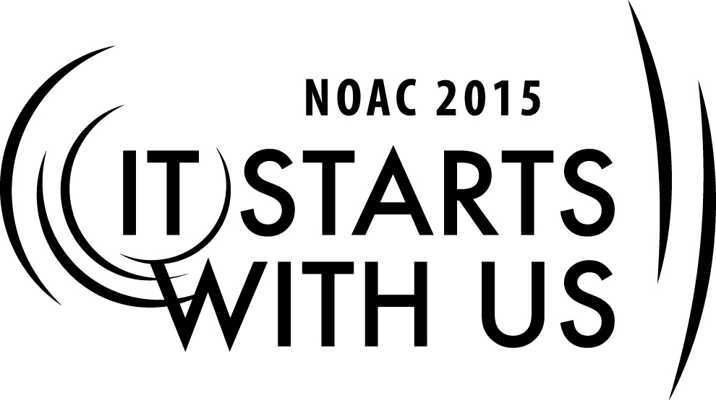
Adult vs. Youth Role:
Role of the Adults in the O.A.
2015 National Order of the Arrow Conference
Session Length: 50 Minutes
Through this session, you will:
Explain: to assess the value and role of the adult in the Order
Demonstrate: explore the fundamental ingredients for the adult
Guide:
Enable: discuss the relationship of the adult with the youth

This session will help the **Lodge/Chapter/Section** with the Journey to Excellence Requirement(s) #16

The theme of NOAC 2015 is “It Starts With Us”. This session will relay this theme in the following ways:
- **type how the theme will be relayed**

SESSION NARRATIVE

Youth and Adult Roles 50 Minutes

Introduction: 2 – 4 minutes

We should take a moment to answer a simple question: Why are we here? More importantly, what is it that we are supposed to do? During the 1992 presidential race, third party candidate Ross Perot had picked James Stockdale as his running mate. At the vice presidential debate, Admiral Stockdale began by asking something very similar.

Unfortunately, voter reaction and the media commentary were not very favorable. What he intended as a joke, ended up branding him as old, senile, and out of touch. So hopefully, as we answer those same questions, the youth that we serve won’t come to the same conclusions.

So back to our original question, why are we here? Well, the answer to that is very simple: To accomplish the Purpose of the Order of the Arrow and fulfill the Mission of the Lodge. It is really technically that simple. Technically, well, if that’s what we are supposed to do, then let’s take a quick look at these guiding principles.

As Scouting’s National Honor Society, our purpose is to:
Recognize those who best exemplify the Scout Oath ands Law in their daily lives and through that recognition cause others to conduct themselves in a way that warrants similar recognition.

Promote camping, responsible outdoor adventure and environmental stewardship as essential components of every Scout’s experience, in the unit, year-round, and in summer camp.

Develop leaders with the willingness, character, spirit, and ability to advance the activities of their unit, our Brotherhood, Scouting and ultimately our nation.

Crystallize the Scout habit of helpfulness into a life purpose of leadership in cheerful service.

“Mission of the Lodge” 1 – 2 minutes

“The mission of the Lodge is to achieve the purpose of the Order of the Arrow as an integral part of the Boy Scouts of America in the council through positive youth leadership under the guidance of selected capable adults.”

OK, this isn’t the first time you’ve seen or heard of these concepts hopefully, and if it is, then hopefully you have a better understanding of what they are all about. Technically, there policies state clearly what we as an organization are here to do.
Trainer Instructions: Don’t spend a great deal of time on these points, just make sure each participant has a “technical” understanding.

“Are You an Adviser?” 2 – 4 minutes

What are the two ways hat an adult becomes a member of the Order of the Arrow? (Seek group input, but move quickly. You are looking for (1) being nominated by the unit/district/council and approved by the selection committee, and (2) aging in after being inducted as a youth.

How does an adult become an adviser? [Once again seek input. You are looking for the answer that all adults are advisers] We are all advisers by virtue of being over the age of twenty-one. It doesn’t matter if we wear a position patch on our sleeve, have an official title, or appear in the Lodge planbook, we are all advisers in the Order.

Why Are We Really Here?

Now, let me ask another question. What are we really here to do? Or, stated a little differently, why do we do what we do?
Trainer Instructions: Allow the participants to brainstorm ideas why we do what we do in the OA. The purpose of the discussion is to help the participants understand that we do those things to provide opportunities for our youth to develop into leaders with character. Again, move quickly and try to avoid getting bogged down. Ask for simple answer “to give rides”, “to provide money”, etc.

“Why We Do What We Do?”

There are many possible answers to this question. But, at the end of the day, the underlying reason why we do what we do is to provide the young men in our organization with opportunities to develop into leaders with character. Now, understanding that this is why we do what we do, what are some of the tools that we utilize in order to accomplish this worthy goal?
Trainer Instructions: Don’t spend a great deal of time on these points, just make sure each participant has a “technical” understanding.

“What Are the Tools that We Use”

The underlying concept here is that the Order creates leadership opportunities for young people in an effort to fulfill the mission of the Order of the Arrow. There are many ceremonies, event planning, lodge and chapter officers, committee positions, publications, community service projects, and the list is endless. Essentially, we create leadership opportunities by deciding how to best implement the Order’s mission in our councils, then simply implement the “divide and conquer mentality” to share these responsibilities with the young men in the lodge. By utilizing this method, our young men are constantly being charged with accepting responsibility and fulfilling their assigned duties.
The Roles and Personal Qualities of the Adviser 1 – 2 minutes

Given the underlying purpose of the organization previously discussed, we all agree that the Order of the Arrow is a youth-led organization. So, why do we need all of these adults hanging around? In other words, what is the role of the adult in the Order of the Arrow?

We have a tendency to view our adult brothers as merely a source of transportation for the youth, and while it is absolutely necessary to have adult assistance to get our youth where they need to go, we need to be careful not to overlook the other, less obvious benefits of our adult brothers.

For example, one of the most critical functions provided by the adult in our organization is program buy-in. In other words, our unit leaders must have a complete understanding of what we do and what the program is beneficial to their units and the council.

Once we achieve buy-in from a Scoutmaster for our program, then he becomes instrumental in motivating the youth and adult members of his unit to participate in our program.

More importantly, when properly trained and directed, our adult brothers transform into vital coaches and mentors to our young Arrowmen.

Finally, our adult brothers, when properly directed and motivated, provide a needed level of stability and continuity in what is a very dynamic program in terms of youth turnover. The following is a list of the high-level contributions that our advisers can make to the program.

“Role of the Adviser” 20 – 25 minutes

Serve as Positive Role Models: The Mission of the Order of the Arrow directs that we become an integral part of our councils by creating leadership opportunities for our youth >>>” under the guidance of selected capable adults.” Young people need positive adult role models. Properly selected advisers can give wise counsel and offer perspective as someone who had “been there.”

Set the Example of Core Values: Advisers offer an opportunity to set the example of the core values that make Scouting what it is. These opportunities allow youth to see that it is important to think beyond one’s own self-interest and seek to serve others. This unique opportunity provides young people the chance to see how the values learned in Scouting can make a difference in their lives as they move into college, a career field, and family life.

Teach Effective Communication: Advisers offer an opportunity to help youth develop and improve their communication skills. One of the basic tenants of leadership is the ability to communicate with others, in an effort to motivate others to help achieve the objective. As advisers we must be responsive and accessible to the youth we serve. We are no good to the youth if they can never get it touch with us or if we fail to return calls or respond to e-mails. If we fail to respond, we place the youth in position to fail or make decisions without the opportunity to discuss their ideas and gain perspective. We must be timely in our response to whatever is asked of us and provide guidance and encouragement to keep the youth on task. We should encourage the youth to maximize their verbal and written communication skills, as well as listening skills. We also have to listen first and talk second. We need to ask thought provoking questions to allow the youth to examiner what they are doing and hopefully arrive at the correct answer on their own.

Mentor through Example: Advisers should mentor youth, and inspire them to mentor peers. The close relationship that can develop between an adviser and a youth leader presents a prime opportunity to demonstrate the proper way to inspire others and develop leadership qualities in the people they are leading. Our goal should be to help the Arrowmen maximize their potential and achieve more than what they thought they could.

Help Set Expectations: The adviser helps to set and temper the expectation of youth leaders. An adult, through experience, offers the youth the ability to learn from the mistakes of others and adapt future plans to avoid potential pitfalls.

Provide Perspective: The adviser has the opportunity to help the youth leader understand the big picture of the Order and Scouting. This relationship is key to developing potential future advisers, Scouting volunteers and community leaders by showing motivated young people that they can make a difference in charting the direction of what is happening around them.

Coach the Youth: In an athletic event a coach is not the one who goes out and makes the play to help the team to a win. As a coach, the adviser’s role is to help the youth identify the talent and abilities that they already possess, grow the ability and use it to accomplish the objective.

Be a Teacher: As an adviser, we should show the youth leader how to accomplish a task that he may not be familiar with and equip him to be able to accomplish the task on his own and be able to impart his knowledge to others. Learning is accomplished when a person is shown how to do something and then presented with the opportunity to do it.

Provide Feedback and Evaluation: As an adviser, we should help the youth learn to take a step back and take a look at what they have done and note what went right and what went wrong.

Support the Youth: As an adviser, we have to show up and be there if the youth needs help. We must empower the youth to make the decisions and give them the latitude to use their judgment to accomplish the task. We also provide or open doors to available resources. And yes, sometimes it means that we need to provide them with transportation.

Provide Enthusiasm and Exude a Positive Attitude: Our attitude is contagious as advisers. If we are negative or critical about what we have to do, then the youth will develop that mindset as well. We need to be excited about what we are doing and create a fun environment that will encourage the youth to want to be involved. Being negative is the easy way out. It sends the message that sitting back and complaining is better than rolling up your sleeves and working to change something or accomplish the task in spite of challenges. Not only are we coaches, we’re also cheerleaders as well.

Ensure Proper Recognition: Make sure the youth get the credit they deserve and deflect criticism if something goers wrong. A problem can be a roadblock for future opportunity, if it causes the person to want to give up and walk away. Proper recognition will give the youth a good feeling and inspire them to a deeper commitment going forward.

To Be Knowledgeable Ourselves and to Provide Training Opportunities to the Youth: In order to be effective advisers, we must be knowledgeable ourselves. We have all heard the phrase “every boy deserves a trained leader”. That applies to the Order of the Arrow as well. Your participation here in this training session is part of that. Seek out opportunities to learn about this program. At the same time encourage and enable youth to participate in training opportunities as well.

To Allow the Youth to Lead: Our relationship is a lateral one, not top down. Our leadership should remain in the background and as subtle as possible, giving the youth the opportunity to publicly lead. Sure, you and I could probably do a better job getting out timely newsletters, organizing a LLD, or running a lodger activity. But that’s not the point. Give the youth the flexibility and opportunity to do it themselves. Will they always be great? Most likely not. Will they sometimes fail? Most likely! But that is all part of the learning process. As an adviser, my attitude has always been that if it isn’t against the law, BSA policy, or a health risk – it is their decision to make. I will try and counsel them and advise them as to what may be a better way of doing things, but ultimately that decision will be theirs.

The Youth are the Players on the Field: But sometimes “We Have to do a Little Blocking”. An exception to adults staying on the sidelines and letting the youth do all the playing is when it becomes necessary for us to run interference with other adults. Let’s face it; some of us old boys just don’t get it. A lot of times, the youth may be able to handle the situation, but in others. it is entirely appropriate for us to come off the sidelines and throw a block or two – figuratively of course, not literally.

Have Fun: If you are not having fun, something is wrong. If the youth are not having fun something is seriously wrong.
Encourage Future Involvement: As an adviser we should encourage the youth to seek opportunities to expand his involvement and seek growth, while continuing to be committed to his unit.

It is this partnership between our young men and our selected, capable adult leaders that is the very cornerstone of the Order of the Arrow’s program. When all parties fulfill their end of the bargain, this relationship provides a tremendous mentoring experience for the youth, lifelong friendships, and a rewarding experience for all. The nature of this relationship is a powerful one; it forms the very foundation of the success of the Order and sets the Order apart from all other youth leadership organizations.

Summary 3 – 5 minutes

In closing, let’s review some of our major points:
- The mission and purpose of the adult is to guide the youth in accomplishing the mission and purpose of the Order of the Arrow.
- Every adult in the OA is an adviser through his or her attitudes, actions, and words.
- Youth have expectations of what their adult advisers should be. Communicate with your youth and know what his expectations of you as an adviser are.
- Understand your role in the Order of the Arrow. Review the qualities of a good adviser. Learn them, live them, and advise by them!
- If you are ever in doubt as to what job or goal or role may be, take a deep breath. Look down at the strip above your uniform pocket and read the first word – “BOY”. That is why we do what we do. It is not for us – it is for them.

TRAINER PREPARATION

The trainer for this session should be an experienced adult who has or had lodge leadership roles. Former lodge officer or advisers are recommended that show enthusiastic knowledgeable in the functions of the lodge and able to leverage past experience.

Appendix Resources:
- Flipcharts or whiteboard
- Markers
- Power point presentation for this cell
- Projector, computer screen
- Tape

