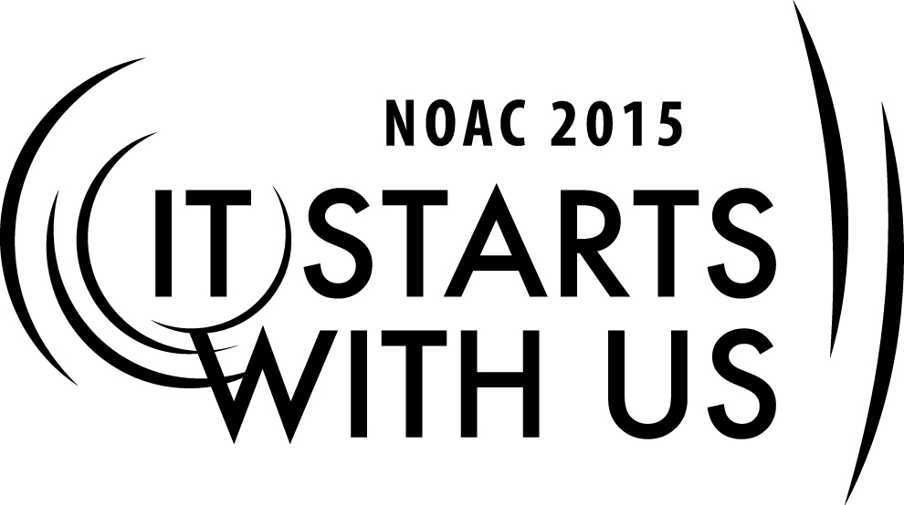
Youth vs. Adult Role:
So You Want to be the Next Chief
2015 National Order of the Arrow Conference
Session Length: 50 Minutes
Through this session, you will:
Explain: the role and basic expectations of being the Chief
Demonstrate: the importance of communications between your fellow officers and advisers
Guide: to discuss the youth relationship in this role as Chief
Enable: to develop a plan of action

This session will help the **Lodge/Chapter/Section** with the Journey to Excellence Requirement(s) 4, 7 and 16

The theme of NOAC 2015 is “It Starts With Us”. This session will relay this theme in the following ways:
- To help guests understand how each member has a responsibility to help spot, encourage and develop youth to step up to leadership roles.
SESSION NARRATIVE

Youth and Adult Roles 25 to 45 Minutes

Know Your Role 3 – 5 minutes

Before discussing the process of becoming the “next Chief”, we need to understand the similarities and differences between the roles of the adult and the youth fill in the Order of the Arrow and the Lodge.

What is your definition of an adviser and the youth officer? (Allow participants about one minute to consider their answer)
Webster’s definition:
An Adviser – one who gives advice
A Youth Officer – one who is elected to hold an office of trust, authority, or command.

They are deceptively simple. They key for us, is how both are chosen. Whether they are for a school board, a corporate board of directors, or a lodge; their peers elect officers, that is to say they are chosen by the youth of the Lodge. They fill the role of the authority figure because they are trusted to lead by the group.

An adviser, on the other hand, is selected. Advisers are authorities based on an appointment, usually due to extensive experience in a particular field. Lodge advisers are usually selected by the council camping committee and appointed by the council scout executive based on their proven ability to work with young people and understanding of the Scouting and the Order of the Arrow programs. However, your staff adviser is selected by the council scout executive and comes from the council’s professional staff. Usually the Lodge adviser based on the similar criteria selects any committee adviser.

Expectations of the “next Chief” 3 – 5 minutes

The big question – What is the Lodge expecting from you? This is an incredibly important question to ask yourself and to answer. Yes, there is criteria outline in the “Guide for Officers and Advisers” and most likely your Lodge has a job description outline in your Lodge’s by-laws. But what about you, what are your expectations?

Ask the groups to provide some expectations. List these ideas on a whiteboard or flipchart
- Attend all meetings and functions of the Lodge.
- Always wear the Scout uniform properly.
- Set the example.
- Be prepared for meetings and presentations.
- Gain consensus of the Lodge Leadership on all Lodge decisions and goals.
- Help establish Lodge goals and directions.
- Attend Section meetings.

As you can see this list can go on and on. These expectations should not be a surprise you. Learning about the obligations after your election is far too late. You should have learned about these expectations and more in a potential lodge officer’s pre-election meeting with the Lodge advisers. At that meeting, the adviser, current lodge officers, verifies that all of those who are running understand the job descriptions and have met all required prerequisites, explain the expectations and the time commitments of the lodge chief, and answer any questions that the candidates may have. This meeting also serves as a common baseline when expectations are not being met.

So, You’ve Been Elected – What Now? 3 – 5 minutes

Shortly after the elections, the Lodge leadership team should meet to further develop their expectations and goals for the up coming year. Some Lodges host post election officer transition training, where former officers lead discussions further explaining the role of the officers and answering and questions that the newly elected may have under the watchful eye of the advisers.

At this training, it is appropriate opportunity to discuss time commitments, compare calendars, and other possible that may get in the way of doing their jobs. Everyone on the leadership team has other commitments outside of those in the Order of the Arrow and these needs to be discussed. The Lodge leadership team needs to be aware of each other’s commitments. These types of obligations need to be understood by all.

Clearly, with all of these obligations, communication is incredibly important. It is imperative that a few ground rules are set on how they should contact each other, by phone, by e-mail, by text messages, what time frame (touching base once a week, meeting two before a major Lodge event) What is your opinion on this?

The final item to be discussed is what each officer brings to the job. Everyone has different abilities and talents. Everyone shapes their own legacy through their actions, their initiatives, and their contacts with other people. Elected officers needs to set a vision for them. They need to ask the following question of themselves.

What skills do I have that will help me in my role?
What impact do I see myself having on the Lodge?
What would I like to accomplish?
1

Acquiring Leadership Skills 3 – 5 minutes

Now that expectations have been set, and we have begun to discuss what challenges, along with the strengths, are brought to the table, we should learn how to gain the skills necessary to overcome those challenges.

The most effective way for us to learn leadership skills, which consist mostly of interpersonal skills, is through relationship building. One form of relationship that is particularly helpful for prospective leaders is mentoring.
Trainer Instructions: Have your groups take about one minute to define the term “mentor”. Take two or three minutes to canvas your audience for an answer. After sharing, connect and simplify the answers to: mentoring is ongoing individual support.

In a mentoring relationship, the experienced leader provides insight, feedback, and friendship to a generally younger, mentee. This relationship maybe initiated by either the mentor or the mentee; however both parties must be willing participants and that this mentoring process falls under the guidelines to the “Youth Protection Policies” of the Boy Scouts of America. In the Order of the Arrow, there are many opportunities for mentorship relationships to form. Some are formal, such as Chapter Chiefs and Advisers, Committee advisers and chairmen, the Lodge Adviser and his Officers, even former Lodge Officers and Advisers and their replacements. Others may be informal relationships between knowledgeable Arrowmen and future Lodge leaders.

The mentor should provide a positive role model, and can direct the mentee to other positive role models. Observation and emulation are parts of human nature. While becoming leaders, both youth and adults need to be exposed to successful Arrowmen who have served as effective officers and advisers.

One of the most important aspects of leadership is interpersonal skill. Many leadership skills, such as project management can be taught in a classroom setting. Interpersonal skills, on the other hand, must be experienced through the “college of hard knocks”. Many youth, and even adults, need to improve their communication, conflict, resolution, and other such skills. Role model and mentors also serve as trainers, sharing valuable experience in these fields and serving as sounding boards to help the mentee develop his or her decision-making skills.

A Training Ground for Leaders 5 to 7 minutes

The Lodge Leadership Team sets the course for the lodge and manages the bigger picture. However, there is another set of leaders in the lodge matrix that should be not be neglected. This set is made up of the lodge committee chairmen.

The Lodge Chief appoints the Committee Chairman, with the approval from the Lodge Adviser. The Lodge Adviser appoints the advisers with the approval of the Council’s Scout Executive. The entire Lodge Leadership Team should be involved in the approval process. These types of leadership positives of committee chairman and advisers provide valuable skill training for the newest leaders. The individuals in these type roles should not just be a “warm body”. Their skills should be match to the position. A scout who is involved in the drama at school may not be interested in being the chairman of the Lodge or Chapter website, but be more interested in working with the ceremonies program of the Lodge. An adult who is a plumber most likely will not be interested in serving on the food committee but be better suited for the Lodge Conservation or Serve project. While managing teams they enjoy, Arrowmen will begin to develop their leadership skills, and their latent talents will be easier to recognize by possible mentors.

Break-out Discussion 9 to 10 minutes
Trainer Instructions: Using the groups that you created at the beginning of this session, have a group break-out discussion on the following scenario.

Scenario: Keith is in his second-term as a Lodge Officer and holds the Lodge Chief position. He would like to create a committee to honor all of the past Lodge Advisers and Lodge Chiefs. He appoints a committee chairman who is a good friend, but has not been very active in Lodge activities for over a year. His Lodge is also the host Lodge for the Section Conclave, a few members have advised him that they do not think the Lodge has enough man-power to adequately handle both events within such a short timeframe. Discuss how you would approach the conflict and eliminate the conflict surrounding these events without endangering the Lodge Leadership Team’s motivation of hosting the Section Conclave.

Life is full of conflicts. One important role of leaders is overcoming these types of conflicts. We all have agendas, where we act upon them or not. These agendas can complicate the path to our actual goal. Staying cool under fire and seeing the bigger picture can help in these types of situations.

Seeking Help 3 to 5 minutes

Sometimes, even the most experienced leader needs a little help now and then. There are resources available to aid in or accomplish a goal. Some of these resources are;
- National OA publications (GOA, FOG, and OA Handbook
- Section Conclaves
- NLS and NLATS
- NOAC
- People (mentors, former officers/advisers, scoutmasters, LAP’s)
- Outside of Scouting (business leaders, leadership books and seminars, teachers, friends, etc.)

Summary 3 to 5 minutes

In closing this session was meant to help you develop a feel for what it takes to be a Lodge Leader.
Remember these items of importance:
- Know your role
- Define your expectations in the role your fulfill
- What skills do I have to make this job easier
- Be open to mentorship
- Stay ground in what you are doing
- Be a leader not a dictator
- Seek help

TRAINER PREPARATION

The trainer for this session should be either an older youth or an adult. The Arrowman should be experienced with lodge leadership (former lodge officer recommended).
Appendix Resources:
- Flipchart or whiteboard
- Markers (different colors)
- Masking tape
- LCD projector
- PowerPoint presentation for this cell
.

