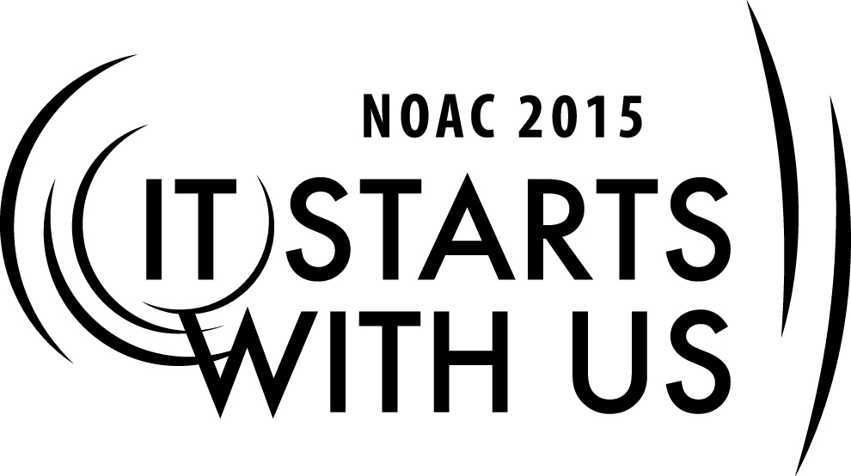
eScouting: Mechanics of Building a Website
2015 National Order of the Arrow Conference

Session Length: 50 Minutes
Through this session, you will:
- Explain – The resources available, structure and process of Building a Website.
- Demonstrate – We will review current websites for structure and references.
- Guide – You will be able to identify resources and proper structure for Building a Website.
- Enable – You will be able to outline a process for Building a Website and know where and what resources to access in Building your Website.
This session will help your Lodge/Chapter/Section with the Journey to Excellence Requirements(s) – #10 – In attending NOAC 2015. #s 3,4,5,6,7,8,9,14,15,& 17 – In implementing a quality Website, upon your return to your home Lodge, your Lodge/Chapter/Section should see an increase in Membership, Program, Council Support and Leadership & Governance through increased quality communication.

The theme of NOAC 2015 is “It Starts With Us”. This session will relay this theme in the following ways:
• We start with developing the foundation of good communication through a quality Website.
• We start with developing the foundation of quality participation through good content, commerce,
connection, customization, community and context in our Website.

Required Materials:
- White Board
- Internet Access
- Power Point presentation file
- Handout – BSA/OA Website Guidelines & Power Point Slides
- Extension Cord
- Presentation Screen/White Board
- Projector
TRAINER PREPARATION

Set up PowerPoint projector. Set up Screen/Presentation background. Set up and test computer. Arrange room in so all seats can see, preferably a semi-circle
The session will be conducted in discussion/participatory format accented with multi-media and/or hands-on exercises.
Trainer Tip: The General flow of the course should include identification of what lodges have for websites, and what works for their lodge with their websites.
Welcome everyone to the session as they arrive and ask them to inter-mix as they sit down.

Introduction: 12-20 Minutes
One of the hardest things for any lodge to do is communicate effectively to all of its’ membership. With the tremendous advances with technology one of the greatest tools for a lodge is utilization of a lodge Website.
How many of you are in a lodge that utilizes a Website as a form of communication? What makes it effective as a communication tool?
[Elicit answers from the participants]
Possible Responses: Interactive Calendar, Bulletin Board, Chat Room, E-mail List, Sign-up,
FAQ (Frequently Asked Questions), Blogs, Surveys,
New Arrowman Resources

Display website http://535badger.wix.com, http://Council589.org
[Display Homepage]. Discuss the layout of the main page. What makes it effective? What catches your attention about the site? Is this page effective? If not, why?
Trainer Tip: Allow the participants to provide answers to each of these questions, while ensuring you get response from as many participants as possible. Try to elicit responses from the quiet guys.

Informational Portion: 25 - 30 Minutes
-Website Traffic and Use (5)
-Website Platforms (4): WORDPRESS, DRUPAL, JOOMLA
- 7 Website Design Elements (5):
1.Content
2.Commerce
3.Connection
4.Communication
5.Customization
6.Community
7.Context

-Website Building Resources [Display Websites]:
SiteSpinner, ,,,,,,,,,
-Website Hosting Resources [Display Websites]:
, ,,,,,,,,
-7 Step Plan in Building a Website (1):
Step 1 — Hosting
Step 2 — Domain Name
Step 3 — Plan Your Website
Step 4 — Build Your Website Page by Page
Step 5 — Publish Your Website
Step 6 — Promote Your Website
Step 7 — Maintain Your Website

-Social Media Connectivity [Display Websites]:
,,,,,,,,,

Question and Answers 12-15 Minutes
Discussion
1. Q: What are the key elements to accomplish with a Website?
[Elicit answers from the participants]
Possible Responses: Communication, Ease of use, Connectivity, Current/Up to date, Relevance.
2. Q: What do you want, as an Arrowman, from your Website?
[Elicit answers from the participants]
Possible Responses: Ease of access/use, Timely information in the transition of Chapter, Lodge, Section and National Leadership, Timely Responses.
Real World Application: 5 Minutes
Let’s take a look at some resources for when you return home.
[Provide handout packets-BSA/OA Website Guidelines & Power Point Slides]
Note: Remember to work with your Council IT person as Scouting Websites piggy back the Council Websites.
Conclusion: 2 Minutes
Q : Can you design everything for all people?
A: Probably not.
Q: Should you try?
A: Yes as that will lead to an ever desire to improve and in a fast pasted transitional world with continual change in Lodge Leadership it is necessary in order to stay current and relevant.

Appendix Resources:

- PowerPoint Slide Deck
- http://webdesign.about.com/od/beforeyoustartawebsite/p/ build_website.htm, How to Build a Website “aboutTech”, Build a Site in Seven Steps, Jennifer Kyrnin, 2015.
- http://www.websitebuilderexpert.com/how-to-build-a-website, How to Build a Website, Jeremy Wong in Business Tips, February 17, 2015.
- http://www.thesitewizard.com/gettingstarted/startwebsite.shtml, How to Start / Create a Website: The Beginner's A-Z Guide, Christopher Heng, thesitewizard.com, 2015.
- http://websitesetup.org/Iwebsitesehttp://websitesetup.org/n help you too!, How to Make a Website, Robert Mening, 2015.
- Hartley, Steven Williams II, Kerin, Roger A., Rudelius, William III. Marketing. 12th Ed., McGraw-Hill, 2015.

