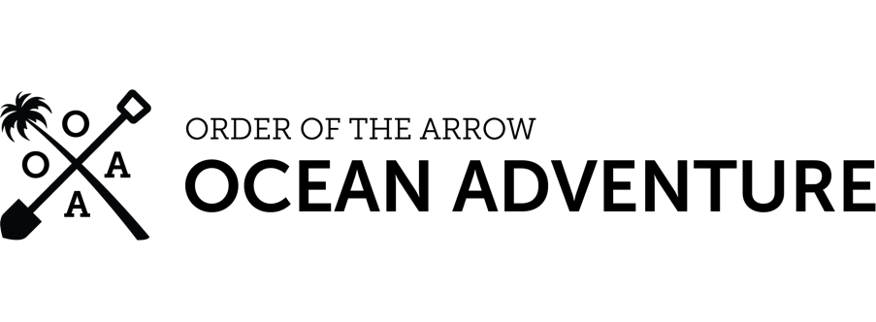

TO:  2025 OA Ocean Adventure Participants

FROM:  Cortland Bolles

National OA Director

Welcome to the National Order of the Arrow Ocean Adventure program at Florida National High Adventure Sea Base. Your crew number will be OAOA-060125 if you are in Session 1 and OAOA-060925 if you are in Session 2. You are scheduled to arrive on the first day of your session and depart on the final day of your session.

Enclosed is your information kit, includes:

* Letter from the National OA Associate Director
* Personal Packing List
* High Adventure Medical Form: [www.bsaseabase.org/scouts/resources/](https://www.bsaseabase.org/scouts/resources/)
* BSA Swim Check Form: [www.bsaseabase.org/scouts/resources/](https://www.bsaseabase.org/scouts/resources/)
* Sea Base Pre-Event Medical Checklist: [www.bsaseabase.org/scouts/resources/](https://www.bsaseabase.org/scouts/resources/)
* Arrival and Departure Information
* Special Dietary Request Form: <https://forms.office.com/r/TNp3iwUcKi>

If you have any questions, call the National OA Associate Director, Brea Baygents, at (972) 580-2175 or at the Florida National High Adventure Sea Base at (305) 664-5640.